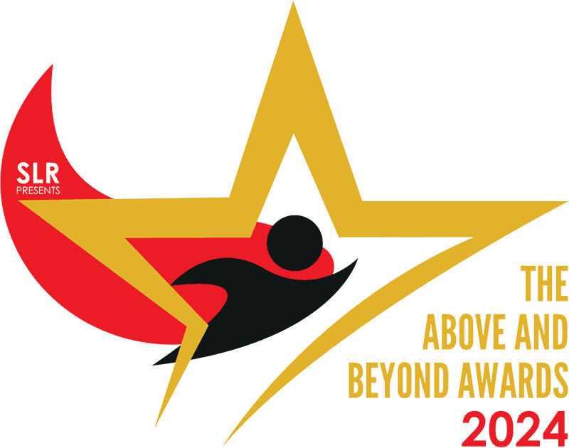

WHAT ARE WE LOOKING FOR?
In the Above and Beyond Awards, the judges will be looking for individuals who have gone Above & Beyond the standard call of duty to make a positive impact on the world around them.

- This could be a positive impact on, for example:
  - fellow colleagues
  - customers
  - the local community
  - local, regional or national charities
  - suppliers or partners
  - anyone else that they come into contact with during their working lives.

- The positive impacts that they have succeeded in delivering could be across any facet of the business, the local area or beyond, for example:
  - Helping improve the performance of the business
  - Practical or emotional support of fellow colleagues or customers
  - Delivering sustainability improvements for the store or the local community
  - Driving positive community engagement
  - Empowering or supporting colleagues or customers
  - Fostering an environment where diversity and inclusion can flourish
  - Supporting local, regional or national charities
  - Taking ownership of challenges in-store
  - Heroic act of bravery

Please note that the lists of examples above are not exhaustive and are provided simply to suggest some areas where you may have witnessed any of your colleagues going Above & Beyond the call of duty.

We know that colleagues in this outstanding sector regularly go Above & Beyond in all sorts of ways – and we want to hear about them to help us recognise and reward those remarkable efforts as well as encouraging others in our sector to follow their lead and continue to ensure that the Scottish local retailing sector is unlike any other sector.

COMPANY-OWNED STORE COLLEAGUE
Open to all colleagues working in CJ Lang Company-Owned stores in Scotland.

To be completed by the person nominating a colleague to win an Above & Beyond Award
YOUR NAME:
YOUR POSITION:
CONTACT NUMBER:
STORE NAME:
LOCATION:
STORE SIZE:

NAME OF NOMINEE:
TIME THEY HAVE WORKED AT THE BUSINESS:
THEIR POSITION:

Why should you or your nominee win an Above and Beyond Award?

What makes your nominee so special within your business?

Please describe all the ways in which your nominee “goes above and beyond” in her or his role?

How do shoppers and the local community benefit from their actions?

How does your business and in-store team benefit from these actions?

How would you describe the effect that your nominee has on those around her or him?

Is there anything else you would like to tell us about your nominee to help us understand why she or he should win this award?

To be completed by the nominee

What do you love most about your job?

What do you see as your most important role or roles at work?

What gives you the most satisfaction at work?

What matters most to you at work?

What are your plans for your career and your future in your store?

SUBMISSION
Please send your completed nomination to events@55north.com.
All nominations should be received before the entry deadline of Friday 12 Jan 2024.
Judges encourage you to send supporting information in addition to your nomination - please send via wetransfer to events@55north.com/, stating the nominee’s name and category in the message box.

Thank you!

